Team Members: Anas Elhadidy, Eizat Mushtaq, Faisal Khan, Milan Ghori
Employee Benefit Management System
Fully Dressed UC2

Revision History
Version | Date | Description | Author
1.0 | 10/01/2018 | First Draft of Fully Dressed Use case 2  Comments:  - Scope: System scope?  - Special Requirements: Seems a bit suspicious. Login failure? Payroll processing fails? And so on  - Technology and Data Variations List: Something more concreate about the technologies and standards used would be stronger. | Anas Hadidy
1.1 | 11/05/2018 | Second Draft of Fully Dressed Use case 2  Updates:  - Stake holders and interests, Preconditions, Post Conditions, Extensions, frequency of Occurrence and miscellaneous updated  - The main success scenario shows step by step process to execute the use case | Eizat Mushtaq

Table of Contents
No. | Contents | Page No.
1. | Fully Dressed Use case | 3
2. | Sequence diagram | 4

Fully Dressed Use case 2:
Name | Make Election
Scope | Business use case
Level | User level goal
Primary Actor | Employee
Stakeholders and Interests | Management- wants to provide benefits to the employee as a part of company policy  Vendor- would like to get customers to enrol with their benefit plans  Employee: Wants to enrol for a benefit plan
Preconditions | Employee has logged to the system and has been authorised.
Postconditions | The system displays the message that “successfully enrolled”
Main Success Scenario | - The employee does Make Election  - Employee arrives at the system  - Employee enter his login details  - The system displays the main menu options to the employee  - With his detail already in the account, the employee is qualified to make an election. He selects the option “Make election”  - The employee enters its details and enrols in a benefit plan.  - The system displays the message “Successfully enrolled”.  - Logs out from the application
Extensions | N/A
Special Requirements | A system which can run the application.
Variations in Technology and Data | The data must be entered through a keyboard.
Frequency of Occurrence | 100 requests/ minute
Miscellaneous | Explore the issue when an employee is unable to enrol for a benefit plan.

Sequence Diagram

Scenario name: Send application for election

Description: In this scenario, the employee can register for a benefit by applying for the election.

Path of the Scenario:
The scenario starts with the condition that the
- system is already running
- the employee authenticates himself to the system.
The path for scenario is:
- The system displays the Employee Main Menu to the employee.
- The employee enters the option corresponding to “make election”.
- The employee enters the detail of each item asked by the system and upon completion gives message as “your application has been submitted”
- The system displays the profile Main menu to the employee.
- The employee selects the option corresponding to logout.
- The system logs out the user from the system.
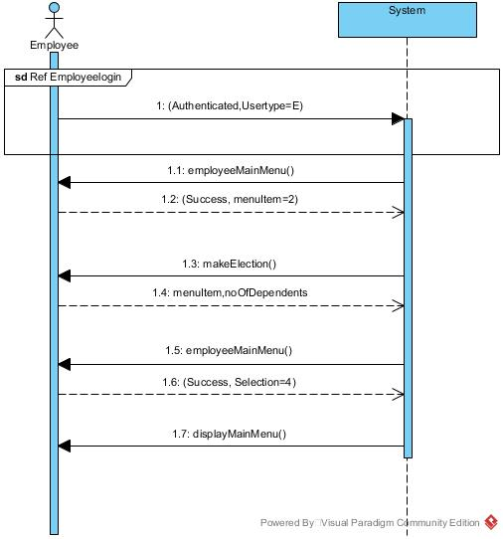
Send application for election sequence diagram

